## Project Title

*Team Mate1, Team Mate2, Team Mate3*

*{mate1,mate2,mate3}@dsu.edu*

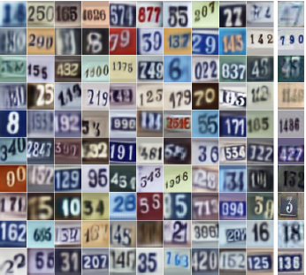

Figure 1. Illustrate your task and/or approach

**1. Task**

Describe the task you are going to solve, e.g. generating natural images like those shown in Fig. 1. Say a few words about what is difficult about the task, e.g. preserving spatial relationships, etc.

**2. Approach**

Outline the approach you took in detail, using diagrams, equations and defining all notation. Do not assume the reader is familiar with the paper you are implementing! If you re-used existing libraries or implementations, say which ones, and say what additional code you wrote for the project.

**3. Dataset**

Say which dataset you used, how many training and test examples, and describe any data pre-processing that was done. The dataset must contain sufficient labels if your project needs them, typical machine learning datasets have 10K-1M examples.

**4. Results**

Describe your experiments evaluating your approach. Define the metric(s) you used, e.g. we used classification accuracy, defined as … State explicitly how you measured success, e.g. “Our results in Table 1 show that our new loss function improved accuracy on the test set of dataset X compared to the method in [4],” etc. Describe all hyper-parameter settings, and analyse the results in detail. What were the lessons learned?

**5. Detailed Roles**

Fill in the table below for each teammate.

|  |  |  |
| --- | --- | --- |
| **Task** | **File names** | **Who** |
| Implemented approach A | modelA.py  etc. | Team Mate1 |
| Wrote data preprocessing code | processdata.py  etc. | Team Mate2 |
| Wrote test code for dataset X | testX.py  etc. | Team Mate1 |
| Wrote sections 1-4 of report |  | Team Mate3 |
| ... |  |  |

NOTE: All reports must follow this exact formatting, including fonts, and must not exceed 8 pages